Chapter 04
Mutual Funds and Other Investment Companies

- Mutual funds offer many benefits. Some of those benefits include the ability to invest with small amounts of money, diversification, professional management, low transaction costs, tax benefits, and reduce administrative functions.
- Close-end funds trade on the open market and are thus subject to market pricing. Open-end funds, are sold by the mutual fund and must reflect the NAV of the investments.
- Annual fees charged by a mutual fund to pay for marketing and distribution costs.
- A unit investment trust is an unmanaged mutual fund. Its portfolio is fixed and does not change due to asset trades, as does a close-end fund. .
- Exchange-traded funds can be traded during the day, just as the stocks they represent. They are most tax effective, in that they do not have as many distributions. They also have much lower transaction costs. They also do not require load charges, management fees, and minimum investment amounts.
- Hedge funds have much less regulation since they are part of private partnerships and free from mist SEC regulation. They permit investors to take on many risks unavailable to mutual funds. Hedge funds, however, may require higher fees and provide less transparency to investors. This offers significant counter party risk and hedge fund investors need to be more careful about the firm the invest with.
- An open-end fund will have higher fees since they are actively marketing and managing their investor base. The fund is always looking for new investors. A unit investment trust need not spend too much time on such matters since investors find each other.
- Asset allocation funds may dramatically vary the proportions allocated to each market in accord with the portfolio manager’s forecast of the relative performance of each sector. Hence, these funds are engaged in market timing and are not designed to be low-risk investment vehicles.

a. A unit investment trusts offer low costs and stable portfolios. Since they do not change their portfolio, the investor knows exactly what they own. They are better suited to sophisticated investors.
b. Open-end mutual funds offer higher levels of service to investors. The investors do not have any administrative burdens and their money is actively managed. This is better suited for less knowledgeable investors.
c. Individual securities offer the most sophisticated investors ultimate flexibility. They are able to save money since they are only charged the expenses they incur. All decisions are under the control of the investor.

- Open-end funds must honor redemptions and receive deposits from investors. This flow of money necessitates retaining cash. Close-end funds no longer take and receive money from investors. As such, they are free to be fully invested at all times.
- The offering price includes a 6% front-end load, or sales commission, meaning that every dollar paid results in only $0.94 going toward purchase of shares. Therefore:
Offering price = 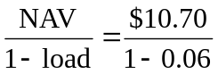= = $11.38

- NAV = offering price × (1 – load) = $12.30 × 0.95 = $11.69

Stock | Value held by fund
A | $ 7,000,000
B | 12,000,000
C | 8,000,000
D | 15,000,000
Total | $42,000,000
Net asset value = 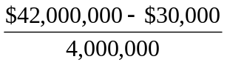= $10.49

- Value of stocks sold and replaced = $15,000,000
Turnover rate = 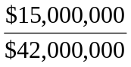= 0.357 = 35.7%

  - NAV = 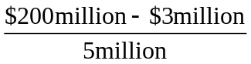= $39.40

  - Premium (or discount) = 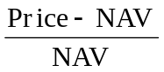 = 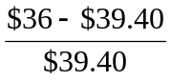= –0.086 = -8.6%
The fund sells at an 8.6% discount from NAV

- Rate of return = 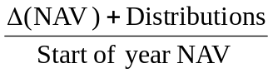 = 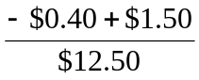= 0.0880 = 8.80%

  - Start of year price = $12.00 × 1.02 = $12.24
End of year price = $12.10 × 0.93 = $11.25
Although NAV increased, the price of the fund fell by $0.99.
Rate of return = 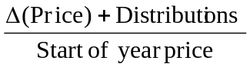 = 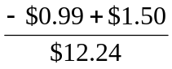= 0.0417 = 4.17%

  - An investor holding the same portfolio as the fund manager would have earned a rate of return based on the increase in the NAV of the portfolio:
Rate of return = = 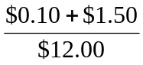= 0.1333 = 13.33%

- Assume a hypothetical investment of $100.
Loaded up
a. Year 1 = 100 x (1+.06-.0175) = 104.25
b. Year 3 = 100 x (1+.06-.0175)^3 = 116.30
c. Year 10 = 100 x (1+.06-.0175)^10 = 151.62

Economy fund
a. Year 1 = 100 x .98 x (1+.06-.0025) = 103.64
b. Year 3 = 100 x .98 x (1+.06-.0025) ^ 3 = 115.90
c. Year 10 = 100 x .98 x (1+.06-.0025) ^ 10 = 171.41

- NAV
a. (450,000,000 – 10,000,000) / 44,000,000 = $10 per share

b. (440,000,000 – 10,000,000) / 43,000,000 = $10 per share

  - Empirical research indicates that past performance of mutual funds is not highly predictive of future performance, especially for better-performing funds. While there may be some tendency for the fund to be an above average performer next year, it is unlikely to once again be a top 10% performer.

  - On the other hand, the evidence is more suggestive of a tendency for poor performance to persist. This tendency is probably related to fund costs and turnover rates. Thus if the fund is among the poorest performers, investors would be concerned that the poor performance will persist.

- Start of year NAV = $20
Dividends per share = $0.20
End of year NAV is based on the 8% price gain, less the 1% 12b-1 fee:
End of year NAV = $20 × 1.08 × (1 – 0.01) = $21.384
Rate of return = 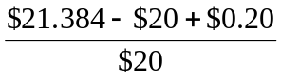= 0.0792 = 7.92%

- The excess of purchases over sales must be due to new inflows into the fund. Therefore, $400 million of stock previously held by the fund was replaced by new holdings. So turnover is: $400/$2,200 = 0.182 = 18.2%

- Fees paid to investment managers were: 0.007 × $2.2 billion = $15.4 million
Since the total expense ratio was 1.1% and the management fee was 0.7%, we conclude that 0.4% must be for other expenses. Therefore, other administrative expenses were: 0.004 × $2.2 billion = $8.8 million

- As an initial approximation, your return equals the return on the shares minus the total of the expense ratio and purchase costs: 12% − 1.2% − 4% = 6.8%
But the precise return is less than this because the 4% load is paid up front, not at the end of the year.
To purchase the shares, you would have had to invest: $20,000/(1 − 0.04) = $20,833
The shares increase in value from $20,000 to: $20,000 × (1.12 − 0.012) = $22,160
The rate of return is: ($22,160 − $20,833)/$20,833 = 6.37%

- Suppose you have $1000 to invest. The initial investment in Class A shares is $940 net of the front-end load. After 4 years, your portfolio will be worth:
$940 × (1.10)4 = $1,376.25
Class B shares allow you to invest the full $1,000, but your investment performance net of 12b-1 fees will be only 9.5%, and you will pay a 1% back-end load fee if you sell after 4 years. Your portfolio value after 4 years will be:
$1,000 × (1.095)4 = $1,437.66
After paying the back-end load fee, your portfolio value will be:
$1,437.66 × 0.99 = $1,423.28
Class B shares are the better choice if your horizon is 4 years.
With a 15-year horizon, the Class A shares will be worth:
$940 × (1.10)15 = $3,926.61
For the Class B shares, there is no back-end load in this case since the horizon is greater than 5 years. Therefore, the value of the Class B shares will be:
$1,000 × (1.095)15 = $3,901.32
At this longer horizon, Class B shares are no longer the better choice. The effect of Class B's 0.5% 12b-1 fees cumulates over time and finally overwhelms the 6% load charged to Class A investors.

- For the bond fund, the fraction of portfolio income given up to fees is:
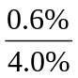= 0.150 = 15.0%
For the equity fund, the fraction of investment earnings given up to fees is:
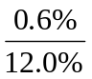= 0.050 = 5.0%
Fees are a much higher fraction of expected earnings for the bond fund, and therefore may be a more important factor in selecting the bond fund.
This may help to explain why unmanaged unit investment trusts are concentrated in the fixed income market. The advantages of unit investment trusts are low turnover and low trading costs and management fees. This is a more important concern to bond-market investors.

  - After two years, each dollar invested in a fund with a 4% load and a portfolio return equal to r will grow to:
$0.96 × (1 + r – 0.005)2
Each dollar invested in the bank CD will grow to:
$1 × (1.06)2
If the mutual fund is to be the better investment, then the portfolio return, r, must satisfy:
0.96 × (1 + r – 0.005)2 > (1.06)2
0.96 × (1 + r – 0.005)2 > 1.1236
(1 + r – 0.005)2 > 1.1704
1 + r – 0.005 > 1.0819
1 + r > 1.0869
Therefore, r > 0.0869 = 8.69%

  - If you invest for six years, then the portfolio return must satisfy:
0.96 × (1 + r – 0.005)6 > (1.06)6 = 1.4185
(1 + r – 0.005)6 > 1.4776
1 + r – 0.005 > 1.0672
1 + r > 1.0722
r > 7.22%
The cutoff rate of return is lower for the six year investment because the "fixed cost" (i.e., the one-time front-end load) is spread out over a greater number of years.

  - With a 12b-1 fee instead of a front-end load, the portfolio must earn a rate of return (r) that satisfies:
1 + r – 0.005 – 0.0075 > 1.06
In this case, r must exceed 7.25% regardless of the investment horizon.

- The turnover rate is 50%. This means that, on average, 50% of the portfolio is sold and replaced with other securities each year. Trading costs on the sell orders are 0.4%; and the buy orders to replace those securities entail another 0.4% in trading costs. Total trading costs will reduce portfolio returns by: 2 × 0.4% × 0.50 = 0.4%

- Suppose that finishing in the top half of all portfolio managers is purely luck, and that the probability of doing so in any year is exactly ½. Then the probability that any particular manager would finish in the top half of the sample five years in a row is (½)5 = 1/32. We would then expect to find that [350 × (1/32)] = 11 managers finish in the top half for each of the five consecutive years. This is precisely what we found. Thus, we should not conclude that the consistent performance after five years is proof of skill. We would expect to find eleven managers exhibiting precisely this level of "consistency" even if performance is due solely to luck.

